Architecture of Internet of Things (IoT)
- Internet of Things (IoT) technology has a wide variety of applications and use of Internet of Things is growing so faster.
- Depending upon different application areas of Internet of Things, it works accordingly as per it has been designed/developed.
- But it has not a standard defined architecture of working which is strictly followed universally.
- The architecture of IoT depends upon its functionality and implementation in different sectors. Still, there is a basic process flow based on which IoT is built.
So, here in this article we will discuss basic fundamental architecture of IoT i.e., 4 Stage IoT architecture.
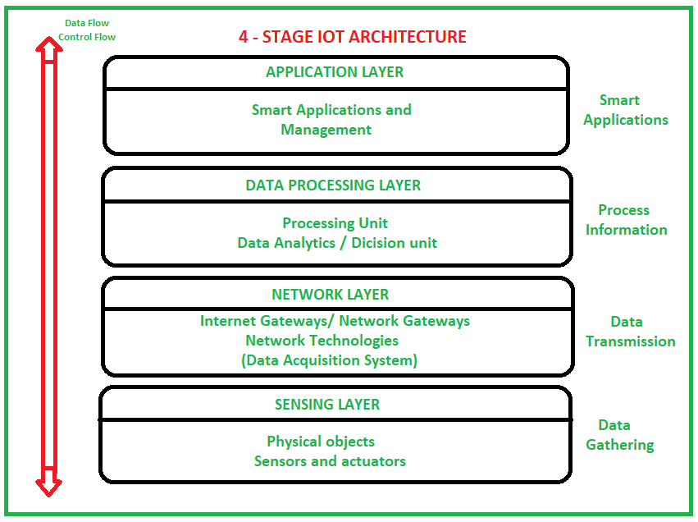
- So, from the above image it is clear that there is 4 layers are present that can be divided as follows:
- Sensing Layer, Network Layer, Data processing Layer, and Application Layer.
- These are explained as following below.
- Sensing Layer –
Sensors, actuators, devices are present in this Sensing layer. These Sensors or Actuators accepts data (physical/environmental parameters), processes data and emits data over network.
- Network Layer –
Internet/Network gateways, Data Acquisition System (DAS) are present in this layer. DAS performs data aggregation and conversion function (Collecting data and aggregating data then converting analog data of sensors to digital data etc).
Advanced gateways which mainly opens up connection between Sensor networks and Internet also performs many basic gateway functionalities like malware protection, and filtering also sometimes decision making based on inputted data and data management services, etc.
- Data processing Layer –
This is processing unit of IoT ecosystem. Here data is analyzed and pre-processed before sending it to data center from where data is accessed by software applications often termed as business applications where data is monitored and managed and further actions are also prepared. So here Edge IT or edge analytics comes into picture.
- Application Layer –
This is last layer of 4 stages of IoT architecture. Data centers or cloud is management stage of data where data is managed and is used by end-user applications like agriculture, health care, aerospace, farming, defense, etc.
The application layer is where end-user applications or business applications reside. These applications leverage the data collected from IoT devices to provide insights, make decisions, and trigger actions. Applications can range from smart home systems and industrial automation to healthcare solutions and smart cities.

